**SRS Documentation**

**Artwork Management System**

Prepared by

DEBOPRIYO GHOSH

SAIKAT JANA,

MOUSUMI MONDAL,

SARADINDU RANA,

**B.Tech., Sem - V, Group- 1**

**Contents**

1. Data Requirement

2. Assumptions

3. Entity - Relationship Diagram

4. Relationships

5. Relational Schema

6. Normalization of Relational Schema

**Draw the ER diagram; Design the relational schema with minimum redundancy.**

**2. Your old love is still there, however, so you set up a database company, ArtBase that builds a product for art galleries. The core of this product is a database with a schema that captures all the information that galleries need to maintain. Galleries keep information about artists, their names (which are unique), birthplaces, age, and style of art. For each piece of artwork, the artist, the year it was made, its unique title, its type of art (e.g., painting, lithograph, sculpture, photograph), and its price must be stored. Pieces of artwork are also classified into groups of various kinds, for example, portraits, still life, works by Picasso or works of the 19th century; a given piece may belong to more than one group. Each group is identified by a name (like those above) that describes the group. Finally, galleries keep information about customers. For each customer, galleries keep their unique name, address, total amount of dollars they have spent in the gallery (very important!), and the artists and groups of art that each customer tends to like. Each transaction (for the procurement of art-work) needs to be recorded. You can assume more requirement(s) to make your solution more realistic**

**1.Data Requirement**

* Artworks: Every artwork has a unique title; Type is the type of the artwork (e.g., painting, lithograph, sculpture, and photograph), price of the artwork and the year in which it is made (year_of_made).
* Artists: Every artist has an unique id(id) , name of the artist(name), and the style of the art(style_of_art) , age of the artist (age) and address of the each artist(address).
* Customer: Every customer has a unique id and their respective name (name), address and total money spent by the customer (total_spent).
* Group: Each group is identified by a name (name) that describes the group.

**2. Assumption**

1. An artist can create multiple artworks. It is not mandatory that an artist can create only one artwork at one.

**3. Entity Relationship Diagram**

**A. Diagram**

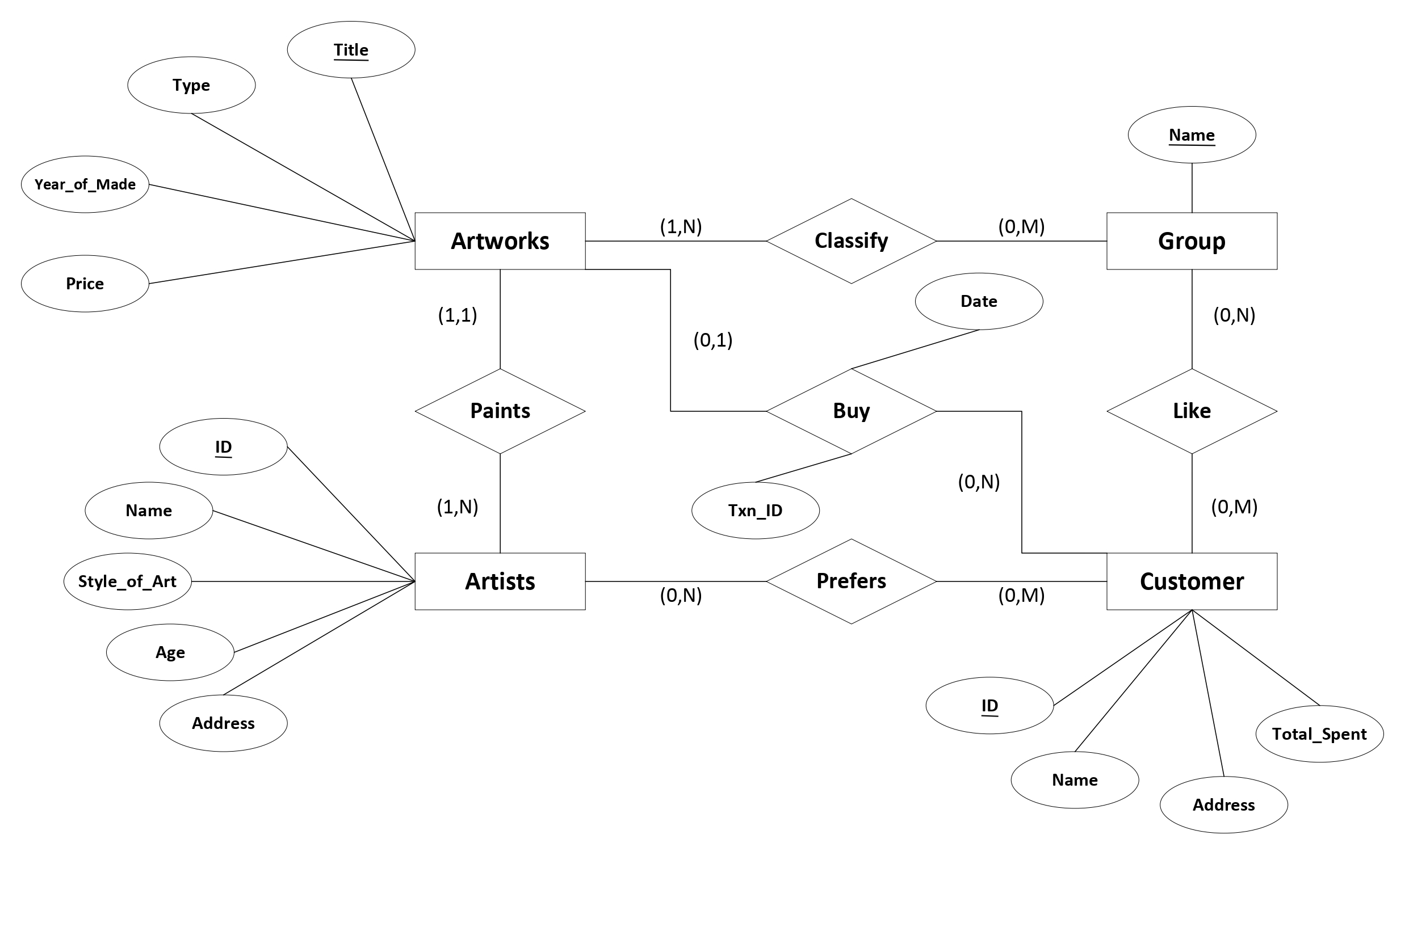

**B. Description**

1. **In this diagram the entities are artworks, artists, customer, Group.**
2. **Artist paints Artworks so they are connected by the relationship ‘paints’.**
3. **Artworks are classified in groups. They are connected by the relationship ‘classify’.**
4. **Customer buys Artworks so they are connected by the relationship ‘buy’. ‘buy’ has two attributes date and txn_id.**
5. **A customer prefers some artists. So customer and artists are connected by the relationship ‘prefers’.**
6. **Customer also likes some Artwork groups so, group and Customer is connected by the relationship ‘like’.**

**C. Attributes**

**Artwork: {Title, Type, year_of_made, Price}**

**Artists: {ID, Name, style_of_art, Age, Addrress}**

**Customer: {ID, Name, Address, Total_spent}**

**Group: {Name}**

**4. Relationships**

**a. Artist-Artworks (1:1) comprises.**

**b. Customer-Artist and Customer-Group (m:n) comprises.**

**c. Customer-Artworks (1:n) comprises.**

**d. Customer-Group (m:n) comprises.**

**e. Artwork-group (1:n) holds.**